INTRODUCTION
This is the third edition of the report on the status of California’s Fish Species of Special Concern (FSSC), those fishes that spawn in freshwater and that may be in danger of slipping to formal threatened or endangered status and from there to extinction. While relying on previous reports and on Moyle (2002) and Moyle et al. (2008), this report follows a standardized system for evaluating status, so our assessments can be easily compared among species and can be repeated by others (Moyle et al. 2011). The Bioregional Assessment of Standardized Conservation Status (BASiCS) protocol was developed by the authors to provide a standard measure of extinction threat directly comparable across all inland fishes in California. Every effort was made to take into consideration all threats, both natural and man-made, facing California’s freshwater fish fauna, while keeping the protocol simple and repeatable so that results are also directly comparable through time. The authors hope that BASiCS will assist multiple generations of biologists and managers in stewarding California’s fish resources by providing standardized, accurate and transparent trend analysis for each of the State’s 129 inland fishes. In some cases, the species discussed are new, the result of recent genetic studies that indicate that many ‘cryptic’ species exist in the state, although most of these forms were, in fact, recognized by early taxonomists but dismissed by later ones.

The inland fishes of California: California has a rich fauna of native inland fishes. The States large size (411,000 km²), length (1400 km and 10 degrees latitude) and diverse topography result in diverse habitats from temperate rain forests to deserts as well as 50 isolated watersheds in which fish evolution has gone in independent directions (Moyle and Marchetti 2006). For most of the state, the climate is Mediterranean; most precipitation falls in winter and spring, followed by long dry summers. This results in rivers that have high annual and seasonal variability in flows (Mount 1995) and native fishes adapted to hydrologic extremes. Of 129 kinds of native inland fishes (defined as those breeding in freshwater) currently recognized, 63% are endemic to the state, with an additional 19% also found in one adjacent state. If other fishes present in trans-boundary watersheds were included, only about five species would be added to the total; thus California has the high overlap between political and zoogeographic boundaries needed for this assessment to be considered bioregional (Moyle 2002).
The coastal and seasonal environment of California has produced a fish fauna containing an unusual number of anadromous taxa (24%) as well as fishes that thrive in isolated environments such as desert springs, intermittent streams and alkaline lakes. A majority of the fishes live in rivers of the Central Valley and North Coast, areas with the most water and most diverse aquatic habitats. The Central Valley in particular has been a center of speciation, with 21 endemic taxa, many of them endemic at the genus or species level, with some also giving rise to species now confined to adjacent watersheds. Recent genetic and taxonomic studies have increased appreciation of the distinctiveness of the California fish fauna, so the total number of distinct taxa has risen from 113 recognized by Moyle and Williams (1990) to 129 recognized today (Moyle et al. 2011).
Unfortunately for the fishes, most of the rivers of California have been dammed and diverted to move water from places of abundance to places of scarcity, where most Californians live (Hundley 2001). Not surprisingly, native fishes have been in steady decline since the mid-19th century, although the first formal conservation status for the inland fishes was not published until 1989. At that time, 6 species (5%) were regarded as extinct in the state, 15 (13%) were formally listed as threatened or endangered under state and federal Endangered Species Acts and 50 (43%) were regarded as imperiled (Moyle et al. 1989). There has been only one recognized extinction in the intervening years but the numbers of listed and imperiled species have steadily increased so that in 1995, the numbers were 18 (16%) listed and 53 (46%) imperiled (Moyle et al. 1995). Today, the numbers are 30 (23%) listed and 69 (54%) imperiled which means that 83% of California’s native fishes are now imperiled or extinct (Fig. 2).

References cited:
Hundley, N. 2001. The great thirst: Californians and water-a history. University of California Press.
Mount, J.F. 1995. California rivers and streams: the conflict between fluvial process and land use. University of California Press.
Moyle, P.B. and J.E. Williams. 1990. Loss of biodiversity in the temperate zone: decline of the native fish fauna of California. Conservation Biology 4:275-284.
Moyle, P.B., R.M. Yoshiyama, J.E. Williams. And E.D. Wikramanayake. 1995. Fish species of special concern of California. 2nd edition. California Department of Fish and Game, Inland Fisheries Division, Rancho Cordova, CA 272p.
Moyle, P.B. and M.P. Marchetti. 2006. Predicting invasion success: freshwater fishes in California as a model. BioScience 56:515-524.
Moyle, P.B., Israel, J.A., Purdy, S.E., 2008. Salmon, Steelhead, and Trout in California: Status of An Emblematic Fauna. Center for Watershed Sciences, University of California, Davis. <http://watershed.ucdavis.edu/> (accessed August 2011).
Moyle, P.B., J.V. Katz and R.M. Quiñones. 2011. Rapid decline of California’s native inland fishes: a status assessment. Biological Conservation. 144:2414-2423.
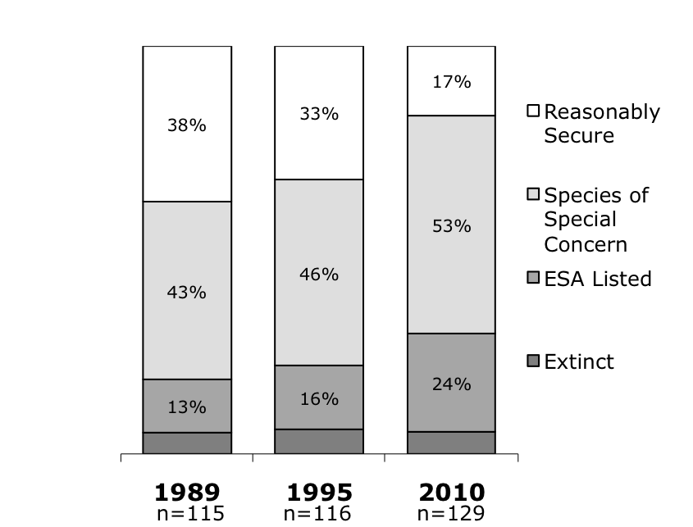
Figure 1. Official status of the inland fishes native to California, 1989- 2010.
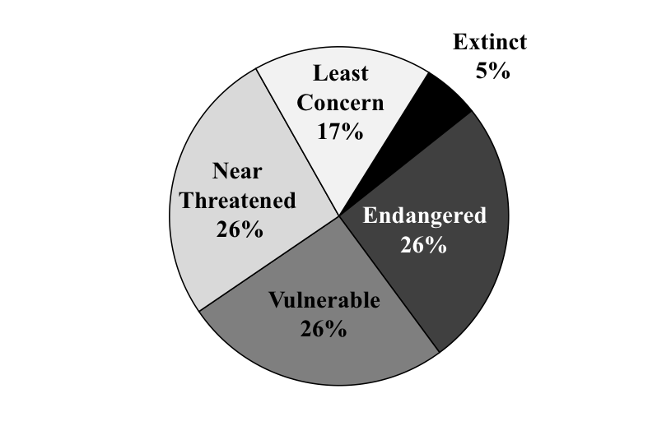
Figure 2. Conservation status of fishes (N = 129) native to inland waters of California, 2010. Data from Moyle et al. 2011.

METHODS
Species accounts: A species account was created for each fish taxon known to spawn in the inland waters of California. Accounts represent the synthesis of all available information for that taxon presented in a standard format (Table 1). Literature cited is provided as a separate section at the end of the report, rather than at the end of each account, to reduce redundancy.

Table 1. Standard format of fish species accounts
I. Status Summary
Species status category (Table 2) with a 1-3 sentence description of current conservation threats
II. Species description
III. Taxonomic relationships
Summary of latest systematics
IV. Life history
Synthesis of all known information pertaining to life history
V. Habitat requirements
Covers all life history stages and includes basic physiological tolerances (temperature ranges etc.), where information is available
VI. Distribution
Present and historic range of the species
VII. Trends in abundance
An assessment of both long and short-term trends, using quantitative data where it exists but otherwise assessments are based on whatever information is available
VIII. Nature and degree of threats
A descriptive catalog of threats to the species, including a standardized table of anthropogenic factors limiting population (Table 7)
IX. Effects of climate change
An evaluation of the likely effects of climate change on the species in the next 100 years. Background for this section, including climate change models used for analysis, can be found in a white paper prepared for the Public Interest Research Program of the California Energy Commission (Moyle et al. in press)
X. Status determination
Each of seven extinction metrics are scored on a 1-5 scale (Table 3) then averaged to produce a final status score (Table 4). This section also contains a certainty estimation based on the quality and quantity of the data (Table 5) as well as a discussion of federal status listing (if any), American Fisheries Society status (Jelks et al. 2008) and NatureServe status
XI. Management recommendations
This is a discussion of what is being done, or proposed to be done, as well as what should be done in the opinion of the authors
XII. California Range Map

Maps included are based on synthesis of all relevant information in the species accounts.

Sources of information Taxa used are those that fall under the definition of “species” under the federal Endangered Species Act of 1973, which included species, subspecies, Evolutionary Significant Units, and Distinct Population Segments recognized by one or more agencies. Information on the biology and status of each species was derived from detailed reviews in Moyle et al. (1995), Moyle (2002), Moyle et al. (2008), Moyle et al. 2010, Moyle et al. (2011), collection of all scientific literature and agency reports issued since the last published review, and by personal communications with biologists working with each taxon. All species accounts underwent extensive peer-review by species experts. In a few cases, information was updated by field investigations by the authors. The status of each species is as of January 1, 2011.

Evaluation of status Status assessments were produced from information contained in each account with the use of a standardized protocol designed to quantify threat of extinction (Tables 2-7). Status was determined by averaging the numeric scores given to seven extinction threat metrics (Table 3). Each metric was standardized on a 1-5 scale, where ‘1’ was low (negative effect on status) and ‘5’ was high (no or positive effect) and ‘2’ through ‘4’ were intermediate. Threat level ratings are roughly equivalent across metrics. Collectively the metrics were designed to cover all factors affecting freshwater fish status in California with minimal redundancy between metrics. Scores for each metric were awarded according to a standardized rubric (Table 4) and then averaged to produce an overall numeric threat score for each species. A principal components analysis using scores for the entire native freshwater fish fauna of California indicated that no one metric dominated the final threat score (Moyle et al. 2011).
To facilitate global understanding of our assessment, the scoring rubric was calibrated to correspond to IUCN status categories (Table 2). Fishes scoring between 1.0 and 1.9 were labeled critical concern and regarded as being in serious danger of extinction in their native range. Species with scores between 2.0 and 2.9 were labeled high concern and considered to be under severe threat but extinction was less imminent than in species with lower scores. However these species could easily slip into the first category if current trends continue. Species scoring 3.0 - 3.9 were considered to be under no immediate threat of extinction but were in long-term decline or had naturally small isolated populations which warrant frequent status re-assessment, thus they were labeled moderate concern. Taxa scoring 4.0 to 5.0 were regarded as of low concern in California. The scores only apply to populations that spawn in California so species with a wide distribution outside the state (e.g., pink salmon) could receive low scores within the state, reflecting California’s position at the edge of their range.
Information regarding California fishes had been previously summarized in Moyle (2002), Moyle et al. (2008) and Moyle et al. (2010). Data compilation and status assessment methodology were thoroughly described in Moyle et al. (2011).

Table 2. Conversion of numeric status scores to verbal status category definitions. To facilitate understanding the conservation implications of the ratings, the scoring rubric was calibrated to correspond to IUCN status categories at each integer break.
Status Category,  this report | IUCN Status  Category | Definition | Scores
Extinct | Extinct | Globally extinct or extirpated from inland waters of California | 0
Critical Concern | Endangered | High risk of extinction in the wild. Range seriously reduced or greatly restricted in California, population abundance critically low or declining. Threats projected to reduce remaining California habitat and populations in the short-term (<10 generations) | 1.0 - 1.9
High Concern | Vulnerable | High risk of becoming a critical concern species in the wild. Range and abundance significantly reduced. Existing habitat and populations continue to be vulnerable in the short-term (<10 generations) | 2.0 - 2.9
Moderate Concern | Near-threatened | Declining, fragmented and/or small populations possibly subject to rapid status change. Management action needed to prevent increased conservation concern. | 3.0 - 3.9
Least Concern | Least  Concern | California populations do not appear to be in overall decline; abundant and widespread | 4.0 - 5.0

Table 3. Scoring rubric used to assign scores to the seven status metrics used to assess status of native freshwater fishes in California. Final status score is the average of all seven metric scores.

1A. Area occupied: resident fish
- 1 watershed/stream system in California only, based on watershed designations in Moyle and Marchetti (2006)
- 2-3 watersheds/stream systems without fluvial connections to each other
- 3-5 watersheds/stream systems with or without fluvial connections
- 6-10 watersheds/stream systems
- More than 10 watersheds/stream systems

1B. Area occupied: anadromous fish
- 0-1 apparent self-sustaining populations
- 2-4 apparent self-sustaining populations
- 5-7 apparent self-sustaining populations
- 8-10 apparent self-sustaining populations
- More than 10 apparent self-sustaining populations

2. Estimated adult abundance
- ≤500
- 501-5000
- 5001-50,000
- 50,001-500,000
- 500,000 +

3. Dependence on human intervention for persistence
- Captive broodstock program or similar extreme measures required to prevent extinction
- Continuous active management of habitats (e.g., water addition to streams, establishment of refuge populations, or similar measures) required
- Frequent (usually annual) management actions needed (e.g., management of barriers, special flows, removal of alien species)
- Long-term habitat protection or improvements (e.g., habitat restoration) needed but no immediate threats need to be dealt with
- Species has self-sustaining populations that require minimal intervention

4. Environmental tolerance under natural conditions
- Extremely narrow physiological tolerance in all habitats
- Narrow physiological tolerance to conditions in all existing habitats or broad physiological limits but species may exist at extreme edge of tolerances
- Moderate physiological tolerance in all existing habitats
- Broad physiological tolerance under most conditions likely to be encountered
- Physiological tolerance rarely an issue for persistence

5. Genetic risks
- Fragmentation, genetic drift, and isolation by distance, owing to very low levels of migration, and/or frequent hybridization with related fish are the major forces reducing genetic viability
- As above, but limited gene flow among populations, although hybridization can be a threat
- Moderately diverse genetically, some gene flow among populations; hybridization risks low but present
- Genetically diverse but limited gene flow to other populations, often due to recent reductions in connectivity
- Genetically diverse with gene flow to other populations (good metapopulation structure)
6. Vulnerability to climate change
- Vulnerable to extinction in all watersheds inhabited
- Vulnerable in most watersheds inhabited (possible refuges present)
- Vulnerable in portions of watersheds inhabited (e.g., headwaters, lowermost reaches of coastal streams)
- Low vulnerability due to location, cold water sources and/or active management
- Not vulnerable, most habitats will remain within tolerance ranges

7. Anthropogenic threats analysis
- 1 or more threats rated critical or 3 or more threats rated high–indicating species could be pushed to extinction by one or more threats in the immediate future (within 10 years or 3 generations)
- 1 or 2 threats rated high- species could be pushed to extinction in the foreseeable future (within 50 years or 10 generations)
- No high threats but 5 or more threats rated medium- no single threat likely to cause extinction but all threats in aggregate could push species to extinction in the foreseeable future (the next century)
- 2-4 threats rated medium- no immediate extinction risk but taken in aggregate threats reduce population viability
- 1 medium all others low- known threats do not imperil the species

Table 4. Demonstration of a scored assessment table, using status of California golden trout as an example. Each metric is scored on a 1-5 scale where 1 is a major negative factor contributing to status, 5 is a factor with no or positive effects on status; and 2-4 are intermediate values. Scores are awarded according to the rubric in Table 3.
Metric | Score | Justification
Area occupied | 1 | Genetically “pure” California golden trout are confined to a few small tributaries in one watershed
Estimated adult abundance | 3 | Tributary populations show signs of genetic bottlenecking but probably still contain 100-1000 adults
Intervention dependence | 3 | Persistence requires maintenance of upstream migration barriers and continued vigilant management
Tolerance | 2 | Require conditions present in relatively undisturbed small alpine meadow streams
Genetic risk | 1 | Hybridization with rainbow trout is a constant high risk
Climate change | 3 | High southern Sierra Nevada will likely retain significant snowpack, effects of climate change cab be partially mitigated by improved management
Anthropogenic threats | 1 | See Table 1
Average | 2.0 | 14/7
Certainty (1-4) | 4 | Well documented in scientific and agency literature
Information quality. Because the quality and quantity of information varied among species, each species account was rated, on a 1-4 scale, for certainty of status determination (Table 5). A score of 1 represented a species for which the score largely depended on our professional judgment, with little or no published information. Scores of 2 and 3 were assigned to species with ratings based on moderate amounts of published or gray literature or where gaps existed in some important areas. A score of 4 was based on highly reliable information, with numerous accounts in the peer reviewed and agency literature.

Table 5. Certainty of status categories
- Status is based on professional judgment, with little or no published information
- Status is based on professional judgment augmented by moderate amounts of published or gray literature
- Status is based on reports found mainly in the in gray literature with some information in peer reviewed sources but where gaps existed in some important areas (e.g., genetics)
- Status is based on highly reliable information, with numerous accounts in the peer reviewed and agency literature.

Anthropogenic threats analysis. A secondary analysis was conducted of 15 anthropogenic factors (listed below) which limit, or potentially limit, a taxon’s viability (Table 7). Factors were rated on a five-level ordinal scale (Table 6), where a factor rated “critical” could push a species to extinction in 3 generations or 10 years, which ever is less; a factor rated “high” could push the species to extinction in 10 generations or 50 years which ever is less; a factor rated “medium” is unlikely to drive a species to extinction by itself but contributes to increased extinction risk; a factor rated “low” may reduce populations but extinction unlikely as a result; and a factor rated “no” has no known negative impact to the taxon under consideration. Descriptions of most of these factors, with access to literature, can be found in Moyle (2002).

Table 6. Criteria for ordinal ranks assigned to anthropogenic threat factors with correlated time-lines.
Factor Threat Level | Criteria | Time-line
Critical | Could push species to extinction | 3 generations or 10 years which ever is less
High | Could push species to extinction | 10 generations or 11-50 years which ever is less
Medium | Unlikely to drive a species to extinction by itself but contributes to increased extinction risk | Next 100 years
Low | May reduce populations but extinction unlikely as a result | -
None  Not applicable | No known impact to the taxon under consideration  Metric is not applicable to species under consideration | -  -

Major dams. Dams were recorded as having a high impact on a species if they cut off a species from a large amount of its range, if they caused major changes to habitat, or if they significantly changed water quality and quantity downstream of the dam. The effects of the reservoirs created by dams were also evaluated. Dams were regarded as having a low impact if they were present within the range of the species but their effects were either very small or poorly known.
Agriculture. The effects of agriculture were regarded as being high if agricultural return water or farm effluent heavily polluted streams, if diversions severely reduced flow, if large amounts of silt flowed into streams from farmland, if pesticides had significant impacts or were suspected of having them, and if other factors directly affected the streams in which a species lived. Agriculture was regarded as having a low impact if it was not pervasive in the watersheds in which the species lived or was not causing significant changes to aquatic environments.
Grazing. Livestock grazing was separated from other forms of agriculture because its effects are widespread on range and forest lands throughout California, especially the effects of cattle. Impacts are high where stream banks are trampled and riparian vegetation removed, resulting in streams becoming incised and the drying of adjacent wetlands. Removal of vegetation can also result in large amounts of silt being washed into streams, increased summer temperatures, and decreased summer flows. Impacts are low where grazing occurs in watersheds but changes described above are minimal.
Rural residential. As California’s human population grows, people spread across the landscape, often settling in diffuse patterns along or near streams. This results in water removal, streambed alteration (to protect houses, create swimming holes, construct road crossings, etc.), and pollution (especially from septic tanks). Where such housing is abundant and unregulated, it causes major changes to streams and their fishes and is rated as a high impact. Where such housing is present but scarce, the effects are usually low.
Urbanization. When humans concentrate in town and cities, they alter the streams that flow through them to reduce flooding and acquire the water. Pollution is rampant, both through sewage discharges and through less obvious means such as storm drains. Generally, the bigger the city, the bigger its effects on local streams and fish populations.
Instream mining. The most severe instream mining took place during the 19th and early 20th century when miners excavated and dredged river beds for gold, turning them over multiple times. These severe legacy effects are still with us in many rivers. Nearly as severe, at least locally, have been instream gravel mining operations, in which large pits were dug into streambeds and banks altered. Such mining is largely banned (in favor of mining off-channel areas) but also has legacy effects. This was usually rated intermediate when present, although severe legacy affects resulted in high ratings for some species. The impacts of contemporary recreational and professional suction dredge mining for gold can also result in a High rating.
Mining. This refers to hard rock mining, in which tailings can be dumped into streams and pollutants result from mine drainage, mostly of abandoned mines. The effects of mercury mining, used in processing gold in placer and dredge mining is also included here. High ratings come from situation where major mines, even if abandoned, form a major threat because their wastes are poised on the edges of rivers (e.g. Iron Mountain Mine near Redding). Low ratings for species usually come from situations where old mines are present but their effects on nearby streams are not known or not obvious.
Transportation. Historically, river banks were favorite places to construct roads and railroads, so many rivers and creeks have roads and railroads running along one or both sides, often confining the stream channel and subjecting the streams to pollution from vehicle emissions, waste disposal, and accidents. Also culverts and other drainage modifications associated with roads often block fish migration or restrict fish movements. Dirt roads can become hydrologically connected to streams, increasing siltation and changing local flow regimes and seriously impacting aquatic habitat. The ratings were made based on how pervasive roadside streams are in the areas occupied by the species
Logging. Timber harvest has always been one of the major uses of forested watersheds in California, which are also the watersheds that support the most species and highest abundances of fish, including anadromous salmon and steelhead. Logging was relatively unregulated until the mid-20th century, resulting in major degradation of streams through removal of trees as cover and landscape stabilizers. Legacy effects include incised streams with little large wood providing structure and many silt-bottomed reaches. Logging is still a pervasive activity in forested watersheds and is better regulated today than previously, but its effects can still result in siltation of streams, reduced complexity of habitat, and other alterations. High ratings were given when a species occupied streams degraded by either the legacy or contemporary effects of logging. Low ratings were awarded to species that used forested watersheds but where the effects of logging were either mitigated or of small significance.
Fire. Forest, range, and scrub fires are part of California’s natural landscape but human activities have made them more severe (Gresswell 1999; Noss et al. 2006; Sugihara et al. 2006). Transition from relatively frequent understory fires to less frequent but catastrophic crown fires has been shown to be a major driver in the extinction risk of Gila trout (Oncorhynchus gilae) in New Mexico (Brown et al. 2001). There is little reason to think that similar factors are not pervasive in California. A fish species rated high for fire is one in which most of its streams are affected by fire, through increased erosion, increases in temperature, spills of fire-fighting chemicals, and effects of ash and other materials. Low ratings generally applied to fish that lived in areas where fires occur but for various reasons have minimal impact on streams.
Estuary alteration. Many California fishes depend on estuaries for at least part of their life cycle. All estuaries in the state are highly altered by human activity, from siltation to pollution, to diking and draining, to removal of sandbars between the estuary and ocean. Thus the more estuarine dependant a fish species is, the more likely it was to get a high rating for this factor.
Recreation. Human use of streams as playgrounds has greatly increased along with the human population but the effects are usually minor, although concentrated at periods of time when stream flows are low. Recreation is likely to be rated high as a factor when there is, for example, heavy off-road vehicle use in limited habitat, ski resorts that increase sedimentation (from cleared areas for ski runs), or rafters and swimmers disturbing spawning or holding fish (salmon and steelhead).
Harvest. Harvest of fishes is both legal and illegal. Both can have severe impacts on fish populations, especially of large fishes (e.g., sturgeon) or ones that are isolated and therefore easy to catch (e.g. summer steelhead). Many native fishes are not harvested and therefore legal harvest is rarely an issue.
Hatcheries. Most fishes do not have populations supported in part by fish hatcheries but for those that do, hatcheries often have negative effects on wild populations through competition for space and food, direct predation, and loss of fitness and genetic diversity (Kostow 2008; Chilcote et al. 2011). The severity of these effects was rated based in part on hatchery dependence and/or the threat of interbreeding between wild and hatchery populations.
Alien species. Non-native species are present in every California watershed and their impacts on native species through hybridization, predation, competition, and disease are often severe (Moyle and Marchetti 2006). Fish species were rated high in this category if there were studies demonstrating major direct or indirect impacts of alien invaders. They were rated low if contact with aliens was frequent but not negative.

Table 7. Major anthropogenic factors limiting, or potentially limiting, viability of native freshwater fishes of California, using California golden trout as an example.
Threat | Rating | Explanation
Major dams | Low | Isabella Reservoir effects water quality in the South Fork Kern River
Agriculture | No | No known impact
Grazing | High | Pervasive in the area, although less severe than in the past
Rural residential | No | No known impact
Urbanization | No | No known impact
Instream mining | No | No known impact
Mining | Low | Relatively few effects of mining
Transportation | Low | Trails and off-road vehicle routes can be a source of sediment for streams
Logging | Low | This is an important land use in the region but probably has little direct effect on golden trout streams
Fire | Low | Because of fire suppression, headwater areas contain greater fuel loads than historically, although hot fires are unlikely given the sparse plant communities
Estuary alteration | No | No known impact
Recreation | Medium | Off road vehicles are a constant threat, but more so in past than present
Harvest | Low | Potentially a problem; most fishing is catch and release
Hatcheries | Low | Constant threats from hatchery fish to support fishery
Alien species | Critical | Hybridization with rainbow trout is primary extinction threat and a major cause of limited distribution

References cited:
Brown, D.K., A.A. Echelle, D. L. Propst, J.E. Brooks, and W.L. Fisher. 2001. Catastrophic wildfire and number of populations as factors influencing risk of extinction for Gila trout (Oncorhynchus gilae). Western North American Naturalist 61:139-148.

Chilcote, M., Goodson K., Falcy, M. 2011. Reduced recruitment performance in natural populations of anadromous salmonids associated with hatchery-reared fish. Can J Fish and Aquat Sci 68:511-522

Gresswell, R. E. 1999. Fire and Aquatic Ecosystems in Forested Biomes of North America Transactions of the American Fisheries Society 128:193–221

Jelks, H.L., S. J. Walsh, N. M. Burkhead, S. Contreras-Balderas, E. DÌaz-Pardo, D.A. Hendrickson, J. Lyons, N.E. Mandrak, F. McCormick, and J.S. Nelson. 2008. Conservation status of imperiled North American freshwater and diadromous fishes. Fisheries 33:372-386.

Kostow, K. 2009. Factors that contribute to the ecological risks of salmon and steelhead hatchery programs and some mitigating strategies. Reviews in Fish Biology and Fisheries 19:9-31.

Moyle, P.B., Marchetti, M.P. 2006. Predicting invasion success: freshwater fishes in California as a model. BioScience 56:515-524.

Moyle, P.B., Israel, J.A., Purdy, S.E., 2008. Salmon, Steelhead, and Trout in California: Status of An Emblematic Fauna. Center for Watershed Sciences, University of California, Davis. <http://watershed.ucdavis.edu/> (accessed August 2011).

Moyle, P.B., Brown. L.R., Chase, S.D., Quiñones, R.M., 2010. Status and conservation of lampreys in California. In: Brown, L.R., Chase, S.D., Mesa, M.G., Beamish, R.J., Moyle, P.B., (Eds.), Biology, Management, and Conservation of Lampreys in North America. American Fisheries Society Symposium 72, Bethesda, pp. 279–292.

Moyle, P.B., J.V. Katz and R.M. Quiñones. 2011. Rapid decline of California’s native inland fishes: a status assessment. Biological Conservation. 144:2414-2423.

Moyle, P.B., R.M. Quiñones, and J.D. Kiernan. In press. Effects of climate change on the inland fishes of California, with emphasis on the San Francisco Estuary region. California Energy Commission, Public Interest Research Program White Paper CEC-500-2011-xxx

Noss, R.F., J.F. Franklin, W.L. Baker, T. Schoennagel, and P.B. Moyle. 2006. Managing fire-prone forests in the western United States. Frontiers in Ecology and the Environment 9:481-487.

Sugihara N .G., J.W. Van Wagtendong, K.E. Shaffer, J. Fites-Kaulfman, and A. E. Thode, Editors. 2006. Fire in California’s ecosystems. Berkeley: University of California Press.

